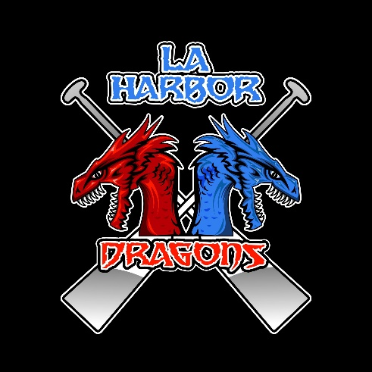

**BECOME A SPONSOR for L.A. HARBOR DRAGONBOAT CLUB**

**Cabrillo Beach Youth Waterfront Sports Center  
3000 Shoshonean Rd.  
San Pedro, CA 90731**

**Sponsorship Levels**:

_____ $500 - Red Dragon

_____ $750 – Blue Dragon

_____ $1,000 – Platinum Dragon

_____ Other Amount

Please submit artwork with this sponsorship form

**All Sponsors Will Have Their Name Acknowledged On:**

* LA Harbor Dragonboat Club Website/Social Media

Sponsor Name: ____________________________________________________

Sponsor Contact Phone Number: _____________________________________

Sponsor Email: ____________________________________________________

**Our Non-Profit Tax No. is 43-3799973**

**For questions & concerns, contact**: [LAHarborDragonboatClub@gmail.com](mailto:LAHarborDragonboatClub@gmail.com)

Sponsorship Form 2025