

SCDBC Dragon Boat Safety Manual 2018

**Table of Contents**

Who Is SCDBC/ICEA? 3

Everyone Is Responsible for 4

Assume nothing! 4

Before Leaving Shore 4

When Returning to the Shore 5

Management – The Steersperson Must Know 6

Physical Skills – Steersperson Must Be Able to 6

Steering Tips 6

Steering Certification Requirements 8

Lesson 1 – Body Positioning, Pivoting, Going in a Straight Line 12

Lesson 2 – Turning 13

Lesson 3 – Steering Backwards 14

Lesson 4 – Fine Tuning 14

To Perfect Your Technique, Practice 15

Steering in Races 17

*U.S. Coast Guard PFD Policy* 29

*Things to Know* 29

Dehydration 30

Hypothermia 30

Heat Related Illnesses 31

# Manual Overview

This safety guide provides essential information for anyone in the SCDBC community, with extra information for those taking on the responsibility of steering a dragon boat in practice and in competition. Reading the manual carefully ensures an understanding of the boating rules and Southern California Dragon Boat Club (SCDBC) safety guidelines. We recommend everyone read the manual once a year for updated information.

# Who Is SCDBC/ICEA?

The ICEA (International Culture Exchange Association) is a non-profit organization promoting cultural awareness and dragon boating. The SCDBC consists of the clubs using ICEA equipment (e.g. dragon boats). The year- around clubs form the SCDBC and its captains are voting members of the SCDBC. They develop the safety guidelines for the organization. These guidelines may be found on the SCDBC Dragon boat website at <http://scdbc.org/>

# Overview of Safety Procedures and Responsibilities

### SAFETY FIRST!

**Who Is in Charge?**

You'll hear many people giving commands but did you know the ultimate person to listen to is the steersperson? **The steersperson is in charge of the boat** – not the caller, coach, or captain, unless they are steering.

While on the water, the steersperson is responsible not only for steering the boat in the right direction but also for the *safe operation* of the dragon boat and *for the safety of everyone onboard*. This requires knowledge of boating safety and safe boating practices. However, everyone has a responsibility to keep things safe. You are even responsible for obeying rules you don't know.

Prior to leaving the beach, you need to be aware of any non-swimmers and have a buddy assigned to the non-swimmer in case of capsize. Typically this would be his/her bench mate. Steers and captains/coaches need to be notified of any crew member with a serious medical condition. Everyone should have learned proper loading and unloading procedures when the boat is docked. Teams must recognize the importance of following all instructions quickly. Steers and captains/coaches are the eyes and ears of your crew while on the water; their instructions must be followed for everyone’s safety.

Someone may want to carry a cell phone for emergencies, but do not accept incoming calls!

ALWAYS BE OBSERVANT OF SURROUNDINGS!

#### *Everyone Is Responsible for*

* The safety of the crew
* The safety of the boat
* The safety of others on or in the water
* The image of your team
* The image of dragon boating to the Long Beach community

#### *Assume nothing!*

* Do not assume your teammates or even leaders know what they are doing
* Do not assume others on the water know what they are doing

#### *Before Leaving Shore*

* Cancel practice if the weather is inclement (heavy rain, strong wind, thunder storms, etc.)
* Steers should check with the beach monitor for the assigned boat, take the correct steering oar, and sign out the boat out on the sheet in the shed
* Check the condition of the boat (benches, gunnels), steering oar, oar bracket; do not use faulty or unsafe equipment. Directly report any damaged or broken equipment to the beach monitor
* When standing in back of boat as a steer – make sure the area is clear of debris and the floor area is not slippery
* Verify that everyone on board is properly wearing an approved PFD
* Identify non-swimmers, people with significant medical conditions and novice paddlers. If possible, do not sit non-swimmers or those with serious medical conditions next to each other
* Load boats from back to front: steersperson, paddlers in reverse order (bench 10, bench 9, etc.), and the caller.
  + Do not load benches which are not "in"/over the water. This will lead to the hull being damaged.
  + When all (or most) benches over water are loaded, carefully push off the shore before the boat becomes too heavy. Load remaining benches and drummer.
  + The boat should be floating and ready for back-paddling at the steersperson's command.
* Be sure that the boat is loaded properly (max persons not exceeded, weight distributed properly – tight to gunwales for side-to-side balance) before leaving the loading area
* Brief the crew on safe behavior and what to do in the event of capsize
* The steersperson should take command of the boat – do not back away from the beach until they determine it is safe, then signal the coach/captain

#### *When Returning to the Shore*

* Be prompt; other teams may be waiting for your boat. If you start your practice late (for whatever reason), you still need to return the boat back on time
* Do not cut across heavy traffic to return to shore
* Check your boat at least two boat lengths from the beach. This serves two purposes: to allow space for departing boats to maneuver and help you avoid a collision, and to avoid damage to the hull bottoms caused by running the boat onto the beach
* After the caller and first three benches exit the boat, lift the boat onto the beach before the remaining paddlers exit
* Follow SCDBC procedures for cleaning the equipment and boat, handing off the boat to another team, and have the Captain or steer sign the boat back in on the sheet posted in the shed. Whoever signs the boat back in has the responsibility of tidying up the shed, regardless of if anyone is practicing after your team

#### *Management – The Steersperson Must Know*

* How many people are on the boat
* Who knows how to swim and who doesn't
* If anyone has a pre-existing medical condition (pacemaker, severe asthma, etc.)

#### *Physical Skills – Steersperson Must Be Able to*

* Manage the loading and unloading of the boat
* Correctly balance the boat
* Maintain a straight course at full racing speed with a full crew of 18-20 paddlers plus the drummer
* Execute an emergency stop (from racing speed to full stop)
* Execute sideways maneuvers without moving forward (paddlers drawing left/right)
* Turn the boat a full 360° in both directions without the use of paddlers
* Propel the boat in reverse for 50 meters with the use of paddlers
* Be able to back into a dock, maneuver to and hold at a gate
* Execute safe approaches to a docks in both calm and windy conditions

#### *Steering Tips*

* Always stand while steering; this gives you better leverage and visibility of the area around the boat. Keep your knees slightly bent with one foot forward.
* Stand as far back in the boat as you can so your oar will be deeper in the water. It will also keep you from interfering with the last bench of paddlers.
* To balance the boat; instruct paddlers to sit with their outside hip to the gunwales and have them get in the “ready” position. Weight affects the boat more in the middle, so swap a heavy paddler for a

lighter one if necessary. An unbalanced boat is an unsafe boat.

* In high side wind, move heavier paddlers to the back to help reduce crabbing sideways.
* Flip-flops or slipper type shoes are NOT allowed because they are easy to slip in. You may wear water shoes or go barefoot.
* Bring your paddle in case the steering oar breaks but do not tuck it in the back of your PFD as you may hit a low bridge with it and fall off the boat. Also, if the boat capsizes, the paddle can become an obstruction and prevent your PFD from working properly.

# Steering Certification Requirements

Requirements may be completed in any order. Practice certification qualifies you to steer during practices without supervision and at local SCDBC races. Upon certification, you will receive a steering number to be worn when steering in Long Beach and at SCDBC events (including tournaments). You may still steer if you forget your number, but only after you’ve informed the beach monitor and only if you are needed to (if other steers are injured or unavailable). You are allowed to replace your number once a year without charge.

### Year-Round/Festival Team Steers:

* (Preferred but no longer a requirement) Be CPR certificated by an organization like the Red Cross or American Heart Association
* Take and pass the online written steering test
* Take and pass the on-the-water portion of the steering test:
  + Gently touch a buoy and hold the bow of the boat at the buoy for 20 seconds
  + Perform a box motion with the boat
    - Move laterally, Draw to one side
    - Back the boat down, paddlers back paddle
    - Draw to the other side, draw on opposite side
    - Move up to start position, paddlers paddle forward
  + A 200 meter mock race, including full start, powers, finish, and an emergency stop as indicated to you by the Certifier
  + Turn around 135 degrees.
  + The start for the mock race should be set up at an angle to the “race course.” Steers will be tested on how quickly they can

adjust the boat back to a straight course(with the width space of a lane or length of the boat towards the start bouy).

* This test is designed to show control of the boat and commands to safely navigate the dragon boat.

Steers in training need a Certified steer displaying a number sitting in the last bench. All requirements (excluding CPR) must be completed by the certification deadline.

Water Tests are to be held during your regularly scheduled practice on your own team’s boat with a minimum of 16 paddlers and a Certifier. Have your captain request a test by submitting a few available times to [steering@scdbc.org](mailto:steering@scdbc.org). Multiple steers can be tested at the same practice.

*Steers can be tested at scheduled group testing sessions or, if your team has multiple steers needing to be tested, request a test by submitting a few available times to* [*steering@scdbc.org*](mailto:steering@scdbc.org)

*\*Festival steers can be tested at scheduled group testing session(s) if we get required minimum signed up for the session(5) or, if your team has multiple steers needing to be tested at practice, request a test by submitting a few available times to* [*steering@scdbc.org*](mailto:steering@scdbc.org)

### Visiting Steers:

* Preferred (but no longer required) CPR certificated by an organization like the Red Cross or American Heart Association
* Fill out a Visiting Steers Questionnaire.

Visiting steers are those not registered to any SCDBC team. They are allowed to steer without supervision at any SCDBC tournament and at the visiting teams practice on the Friday before the Long Beach Festival, but not without supervision during regular practices in Long Beach as they are not SCDBC certified.

The following violations are a few instances where a certified steersperson can lose certification and Long Beach steering privileges:

* Allowing anyone on the boat not properly wearing an approved PFD
* Allowing anyone on the boat who has not signed an SCDBC waiver
* Knowingly endanger anyone, an SCDBC member or the public
* Not complying with SCDBC rules, e.g.
  + racing in non-racing areas
  + making excessive noise while in the quiet zones
  + failing to properly check your boat when approaching the beach
* Not complying with Alamitos Bay Water Rules or federal laws, e.g.
  + steering after sunset without proper lighting
  + cutting the corner buoy in front of the Long Beach Yacht Club
  + steering on the wrong side of center channel/mid-channel buoys
* Not properly displaying one’s assigned Certified Steersperson Number (on one’s back with all four corners secured)
* Steering at the Long Beach Festival in July when not Tournament certified

Depending on severity of the violation, you and/or your team may be suspended before being issued a warning.

**A steersperson needs to be re-certified if inactive status, coming back from a suspension for a steering violation, or partaking in an unsafe manner during practice or race.**

**The person must take the on-the-water test as administered by a Certifier. Every year written tests will also be required.**

It is also recommended that all steerspersons review this manual once a year for updates and changes to rules and regulations.

***THE STEERSPERSON IS RESPONSIBLE FOR FOLLOWING ALL SAFETY NAVIGATION AND RULES INCLUDING ONES YOU MAY NOT KNOW***

# . Knowing Your Boat: Champion Dragon Boats

20-paddler boats – 12.4 meters long, 250 kg (~550 lbs) 10-paddler boats – 9 meters long, 170 kg (~375 lbs)

Both designs have two keels running the length of the boat forming a concave bottom to the hull. They also have a parabolic hull design which means they have no straight areas in the center of the boats.

*View looking top down*

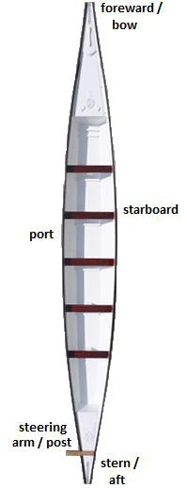

Design weight of IDBF boats is 75kg per paddler (~165 lbs), so if your paddlers average heavier, you have an increased chance of swamping.

# Learning How to Steer

A trained steersperson is an important part of any crew. They are responsible for crew safety and is important to the success of a winning team. A good helmsman will have knowledge of boat commands, and effects of wind and water conditions. The steersperson has the responsibility to make sure all navigation and safety rules are followed.

With practice, a steer will develop instincts of boat balance and create an environment of confidence within the boat. Written information regarding steering is helpful but nothing replaces hours practice in various conditions.

Conduct steer training in calm water and wind conditions away from traffic. A certified steersperson must be in the last bench, close enough to take over the helm if necessary. 20-man boats are recommended for training steerspersons as they are more stable than 10-mans.

#### *Lesson 1 – Body Positioning, Pivoting, Going in a Straight Line*

Do not try to steer a severely un-balanced boat; you will not have full control! To steer well, you must learn to establish a stable stance so you can withstand front- and back- as well as side-forces.

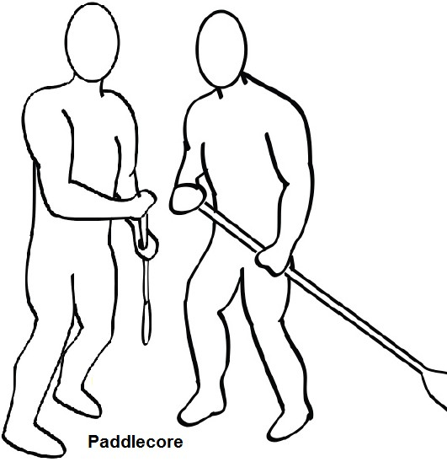*Stance:* Feet should be at least shoulder-width apart. Keep one foot forward and keep your other foot as far aft as possible. It’s easier to stand with your left foot back, because you’ll have more leverage with the oar - but if it feels awkward, just stand the easiest/safest way you can. Keep knees slightly bent and flexible, back straight, hips and shoulders square, except when turning the boat. Keep your core over your knees. This way, if you lose your balance, you will fall down, rather than out.

*Hands and Arms:* Hold the "tee" with the right hand as a paddle, left hand on shaft near your left hip. Your right hand should be near chest height but this will depend on oar length, your height, and other factors. The blade

should be at least halfway below the waterline. This will maintain the proper leverage on the oar required to steer without extraneous force and exertion.

*Stand Up:* **Do not sit** when steering as you will not have the visibility to see ahead or around you. A steersperson should be aware that there may still be a blind spot even though you stand, i.e. you cannot see past the caller/drummer who may be blocking your vision of what is straight ahead. (Tip: tilt your head or wiggle the boat slightly to get a clear view.) Also, hold your oar steady when turning to look for traffic behind the boat. You will also have better leverage when standing.

With the boat not moving, pull the oar handle towards the boat to spin left, push away from the boat to turn right. Keep your eyes forward and do not look back at the oar blade. Be able to spin boat while visually checking the bow and stern/oar as well as looking out for traffic and other obstacles and dangers. Use the oar to stop the turning of the boat. Try not to shift weight and unbalance the boat. More on turning later.

Next, start the boat moving forward. Maintain a straight course while half the boat paddles. Make sure to use the push/pull method and keep the oar blade properly submerged while maintaining correct footing and hand positions. Make small corrections to maintain a straight course. Use a landmark and the bow to maintain orientation along a straight line. Once you get a feel for keeping the boat straight, add power by asking the rest of the crew to join in.

#### *Lesson 2 – Turning*

When you can maintain a straight course and safely stop the boat, execute a left turn at slow to moderate speed. Left turns are easier since you pull the handle inward towards yourself. When turning under power, it is important to make wide turns, as this prevents the boat from rocking and is easier on your paddlers. Make sure you stop the turn and avoid over-steering. After executing a few left turns, try right turns.

* To move head LEFT - push water away from the tail/boat, so PULL the handle towards your body
* To move bow of the boat RIGHT - bring water towards the tail/boat, so PUSH the oar handle away from your body

*Key points:* The deeper the steering oar is in the water, the more resistance on the blade and the more control you will have.

To make sharp turns, first have your paddlers stop paddling, though you do not need to check the momentum. You can have your paddlers help by chumming or drawing water, or by having one side paddle forward while the other paddles backwards. This will tire your paddlers but it will help you.

#### *Lesson 3 – Steering Backwards*

From a complete stop, check for clearance and point the stern in the direction desired. Call for light back paddling. Keep the speed low and make small corrections. Keep the oar blade either entirely out of the water, or only partially submerged. A fully submerged blade runs the risk of catching the water and breaking the oar or sending the steersperson overboard! Have a secure grip on the oar and stable footing. Stop the boat if you lose control! Be aware of the oar blade hitting the sand or dock.

It is safest to fully check the momentum of the boat a short distance from the objective, then call for the minimum strokes to reach the dock or beach.

Remember that your paddlers are in front of you, so they will have difficulty hearing your commands if you give them while looking backward.

#### *Lesson 4 – Fine Tuning*

Learn to point the bow into the wind or water current to maintain the boat's position. Use flags, trees, and the water surface to help determine wind direction. Allow for drift when positioning a boat for a race. Point the bow perpendicular to wakes and waves to minimize impact.

Make turns at regular speed including sharp and gradual turns.

Remember that wind and boat wake can cause a steersperson (and paddlers) to feel uneasy. The best way to handle oncoming boat wake is to turn the front of the boat into the wake, so that the front end hits the wake first and the boat moves up and down rather than side to side. Facing sideways to a series of waves is a situation the helmsman should avoid. The closer to 90**°** (head-on) that the boat meets these waves the less rocking.

#### *To Perfect Your Technique, Practice:*

Tight turns without using paddlers – This is called active steering or tilling.

Tight turns using paddlers – front few paddlers on the inside of the turn can hold water or chum to help you turn more sharply. You can also ask the back few paddlers on the outside to chum as well. To make an even tighter turn, have your middle bench on the inside of the turn check the boat.

Figure Eight –Tight left and right turns (figure 8) around two stationary objects, or one stationary object and one imagined. End where you started.

Box Formation - 10 strokes forward, draw right, 10 strokes back, draw left. End where you started. To keep track of how perpendicular the boat is, practice this maneuver while facing a dock. Or make the box around a buoy, keeping it in the middle of the box. Be aware paddlers do not chum exactly sideways; there will be a forward momentum.

Back Paddle / Reversing towards a stationary object.

Side docking – Dock slowly so paddlers have time to bring their paddles in, and also so the side of the boat does not scrape against the dock. For a bigger challenge, approach the dock at less than 90° angle.

Advanced handle rotation method: Have the top of oar handle (right hand thumb) pointing in the direction of the turn. Turn your wrist left or right to turn. Determine the neutral position of the oar blade with the handle in various positions. This is good during races to make small corrections. Your boat will need to be going at speed for this to work well.

Advanced turning technique - Learn to move your body forward to allow the oar to pass behind your back to make sharp left turns with minimal tilling.

Advanced drift steering – because dragon boats have W-shaped hulls, once you set a turn, your boat will not come back to center unless you re-adjust your oar. In other words, once you start turning, take your oar out of the water and the boat will continue to turn. To stop the turn, put your oar back in the water before you finish the turn and give a good push/pull in the opposite direction. If you have room to make a wide turn, drift steering

(rather than tilling) will prevent you from tiring out. It’s best to drift steer when your team is coasting (not paddling) as you do need a good amount of forward momentum. But use caution because you will have no control when your oar is out of the water.

# Executing Commands and Commanding the Boat:

* SAFETY IS YOUR FIRST PRIORITY.
* Avoid performing other tasks (like coaching) while steering.
* Scan the area in all directions for traffic or other obstacles.
* Be aware of regular traffic patterns:
  + Rowers like to be close to the shore to have a reference since they face backwards.
  + Swimmers are hardest to see and are usually close to shore.
  + Sailboats have right of way and it can be hard to predict their motion so give them lots of room.
  + Generally, kayakers are unfamiliar with their surroundings and the water safety rules. Best to give them plenty of room, slow down and give them verbal (but friendly) warnings of your intentions.
* Give verbal warnings and hand signals to other boats when needed.
* When approaching boats head on and it's unclear which direction they will go, point the bow in the direction you want to go to signal your intentions.
* Use commands and wording consistently.
* Do not be afraid to interrupt the captain or coach.
* Do not wait too long to give a command; paddlers may not be ready and may delay executing the command.
* If time permits, give a short explanation of your intention to the boat: "Let's move away from the dock..." "We're drifting towards shore..." followed by your command.
* Project your voice *with authority* to the front of the boat. Physically point your mouth towards the front of the boat. If you give a command while your head is turned away from the front of the boat, paddles will have a hard time hearing you.

Remember to smile, wave and be friendly to all other people on the water; it’s better to establish goodwill than to make up for a poor reputation.

# Steering in Races

#### *Steersperson’s Job During Races*

* Be familiar with the local race rules and regulations.
* Know the course and water/wind conditions before going out to race.
* Check the condition of the boat and equipment when loading.
* If there is excessive water in the boat, have one or two paddlers bail water while the others paddle to the starting line. Do not waste time to return the bailer, unless instructed to leave bailers at loading.
* Get to the starting line quickly, but stop your boat at least 50 meters away from the lead racing boat to reduce wake for nearby competing lanes.
* Know what lane you are in and where that lane is located. Know the lane buoy situation (number, placement, colors).
* Do not wait too far behind the starting line. You may be too far to hear instructions, and you may not have enough time to move forward to the line before the starter starts the race.
* Unless it is unsafe to do so, follow the starter’s directions, even if you disagree with them.
* Once the starter directs you to your lane, get there quickly, even if you have to turn in front other boats. Make sure there is ample room and try to signal your intentions to them.
* Quickly get into position at the starting line, holding your boat stationary, compensating for wind/current drift.
* Pay strict attention to the starter and make sure your crew does also.
* Signal the starter if your boat is not ready for the race and quickly reposition your boat correctly or in your lane away from the obstruction. Remember that the starter may not wait for you, regardless of whose fault it is that your boat is not ready.
* Once the race has started, steer the boat in the straightest course within your designated lane to the finish line. Use a stationary object past the finish line, not the buoys, as an aiming point. Lane crossing during a race is a violation. Your team will likely be penalized or disqualified. So stay controlled and well within your lane during races.
* If you do cross lanes or if another boat crosses into yours, make sure you stay away from other boats! Do not challenge them, especially if they look like they’ve lost control. If you cannot maintain a safe distance away from the other boat (at least five meters), call a check. It is better to keep everyone safe than to risk a collision or capsize. You can contest the lane violation later.
* ***Call a CHECK as soon as you lose control (not just after you are sure you cannot regain control) or are going to endanger your boat or other boats! Safety is always your first priority, even during competition.***
* You should train your crew to echo your commands in case the drummer does not hear you call an emergency check.
* After crossing the finish line, do not turn back to shore without first looking to see if you are in the way of boats still finishing the race. It is best to be safe and go a bit past the finish line (50 meters or so) before turning back to shore.
* Keeping out of the way of other boats, return to shore as quickly as possible. Departing boats have priority over returning boats.
* Park the boat as the beach marshals instruct you to, generally in numerical order.
* Unload the boat and have your team clear the marshaling area quickly and completely.
* If you are involved in a collision or capsize during the race, or want to file a protest, go the Judges tent as soon as possible. Try not to get too emotional and stick with the facts (not opinions) when protesting.
* We recommend a steer not steer more than eight races a day. Steering can be just as tiring as paddling, if not more so from the mental stress. Exhaustion can lead to impaired decision making, which can be especially dangerous when you’re in charge of the safety of everyone in the boat.

### Tips for Steering at a Tournament

Only employ these techniques if you have mastered them during regular practice times. **A race is not a good time to try something new!**

When racing, think in terms of “tweaking” with minor adjustments as opposed to a more heavy-handed approach. A very beneficial technique during races is to steer only by twisting the steering oar one-quarter turn to either side. At speed, this will have the same effect as pushing the oar to either side, while inducing far less drag. (Also mentioned on page 18 as

“Advanced handle rotation method”)

Turning – Turn about two boat lengths after the start line; this allows for wide enough turns and prevents your team from needing to back up to the start line. Or if you need to back into a dock do not to turn too far ahead of the dock, as you will wear out your crew making them back paddle.

Buoys – If it is too late to realign the boat, run a smaller buoy completely over then return to the center of your lane as soon as you can. This will prevent your paddlers from losing strokes to avoid the buoy. However, if it is a large buoy and your boat cannot run it over completely, know that you may capsize.

Keeping Straight – When at speed, pick a point to steer toward that is 500 meters or more ahead of the boat. Follow lane markers if available. Line up the front of the boat with the selected point and do not let the bow veer off that point by more than 6 inches to either side. Use the handle rotation method of steering (page 18).

Wind – On a head or cross wind, crouch to prevent catching the wind with your body. On a tail wind, make yourself bigger to catch the wind like a sail.

Minimize Drag – If your boat is well balanced and your paddlers have an even (non-bouncy) stroke, you can minimize the use of the steering oar. Bend at the waist and push down on the steering handle so the blade is out of the water. Your boat should stay relatively straight, for a little while at least. Be aware that **you have no steering control while the blade is not in the water**. Attempt this in a race only when you have mastered the technique during practice.

# Alamitos Bay Water Traffic Rules

* Two-way traffic patterns are established by the U.S. Coast Guard. All traffic moves to the right side of the waterway, just like street

driving. Dragon boats should **always keep to the right of the buoy line**. Do not go the wrong way unless necessary to avoid collision.

* An exception is if scullers (rowers) are racing in front of Mother’s Beach. If scullers are present, “hug” the swim buoys on the left and stay away from the scullers on the right until reaching Los Cerritos Channel (Marine Stadium).
* **The least maneuverable craft has the right-of-way**. **But when in doubt, give-way!**
* Dragon boats give way to sailboats, and large powered vessels.
* Paddles boats *usually* have right-of-way over motor boats because we are harder to maneuver, ***but do not challenge them!***
* When crossing the path of another vessel, the boat on the right is the stand on vessel (which means they have the right of way). The other vessel is the give way vessel.
* When approaching at right angles and at risk of a collision, **yield to the boat ahead and to the right of you.** You must direct your course to the right and pass behind the other boat. **If necessary you should slow, stop or back paddle.** Never turn your boat to the left during a crossing situation. Doing so may result in a serious collision.

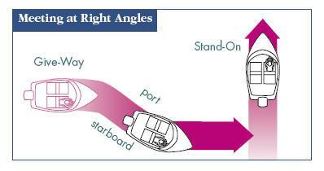

* **When overtaking another vessel, give right-of-way and keep clear.** When a dragon boat is approaching a slower boat (e.g. kayaks, sculls) and wishes to pass, first **make sure there is safe open water to pass**, alert the people in the other boat of your intentions and then safely take the widest clearance possible to pass (keep clear). Many people are vacationers and are not adept at maneuvering their

boats. ***Remember that we have a responsibility to the Long Beach community to help keep its waters safe.***

* **Five short whistle blasts alert others to a dangerous situation.**
* **Marine Stadium waters are off limits to dragon boats** unless specified otherwise.
* **We do not have the right to stop at private docks**. The long dock in front of the Long Beach Yacht Club, the Marine Department dock, and the American Pride dock are accessible to dragon boats.
* Lights are required to be used after sunset, for proper identification and general safety.
* The Quiet Zone is in force **at all times** in the following areas:
* all waterways surrounding and within Naples Island – this includes waterways adjacent to the peninsula across from Naples Island
* any other waterways adjacent to private residences

Please use your judgment about noise levels when not in Quiet Zones.

* The Marine Department has asked dragon boats NOT TO RACE:
* in the area between LONG BEACH YACHT CLUB and MARINE STADIUM. This includes underneath the Davies Bridge, in front of Mother's Beach and in front of Marine Park
* in the Naples Canals
* in close proximity to other boats or swimmers

**Racing is defined as 2 or more boats paddling at full power within a close vicinity of each other.**

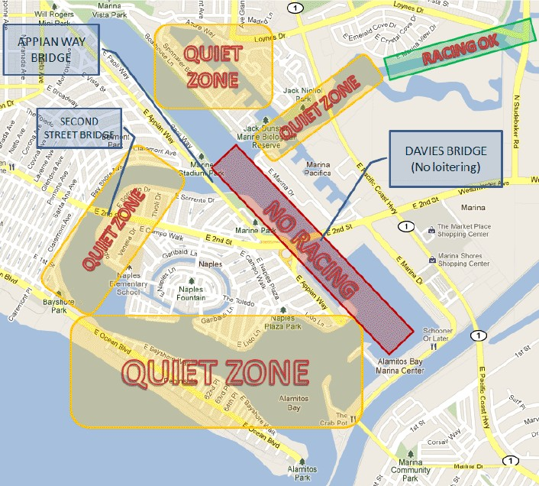

The Marine Department has asked dragon boats NOT TO LOITER:

* + in front of Davies boat launch ramp (directly across Mother's Beach)
  + under any bridges
  + in the middle of any waterways

Please "pull over" when speaking to your team or with another boat. Steers should continue to look around for traffic.

Additional rules of the road (waterways) for dragon boaters in Alamitos Bay:

* GO COUNTER-CLOCKWISE (i.e. keep the harbor walls on your right). Do not go clockwise; someone else may be just around the corner expecting the way to be clear. However, you are allowed to go

clockwise if the scullers are running a race in front of Mother’s Beach.

* Dragon boats may not leave the Alamitos Bay waterways nor enter the open ocean past the breakwater.
* Beware of boats with running engines - they are likely to depart.
* Beware of wakes and the ricochet of wakes.
* Try to orient the boat to take waves at right angles, i.e. on the nose or stern. Continue paddling your current speed as you cut through the waves. If you have a clear path ahead, do not stop or slow the boat. If you do not have a clear path, stop and brace the boat.
* Weather indicator pennants are displayed at the Fireboat station behind the fuel dock. You should seriously consider cancelling practice if a small craft warning is displayed. If the pennant flown is more severe than a small craft warning, return to shore immediately.

Weather Pennants appear either individually or as doubles. When displayed as a pair, they indicate a more severe warning.

|  |  |  |  |
| --- | --- | --- | --- |
| warn.gif (1042 bytes)  The small craft warning indicates a forecast of high winds up to 33 knots (38 mph) | Winds predicted between 34 and  47 knots  (39 - 54 mph) | storm.gif (1091 bytes)  A "whole gale" warning signifies winds of between 48 and 63 knots  (55 - 73 mph) in the case of a tropical cyclone | A tropical cyclone with winds exceeding 64 knots  (74+ mph) |

# Infractions and Penalties

#### *Infractions in order of severity:*

1. Personal injury – to paddlers, beach goers, boaters, etc.
2. Damage to Public property – city bridges, public docks, etc.
3. Damage to Private property – private docks, boats, paddle boards, etc.
4. Damage to SCDBC property – dragon boats, steering or paddling equipment
5. Safety infraction – paddling on wrong side of channel, racing in prohibited areas, incorrectly/not wearing PFD (either self or paddlers), etc.
6. Non-safety infraction – incorrectly/not wearing steering number, disregard of quiet zones, not slowing the boat when beaching it, etc.

#### *Penalties in order of severity:*

1. Temporary suspension of team practice
2. Permanent ban of steering privileges
3. De-certification of steersperson
4. Temporary suspension of steering privileges
5. A written or public warning
6. A verbal warning

### The SCDBC knows that accidents will happen, but negligence will not be tolerated!

If you are involved in an accident of **any** kind, report it to the beach monitor and the SCDBC administrators as soon as possible: [steering@scdbc.org](mailto:steering@scdbc.org), [info@scdbc.org](mailto:info@scdbc.org) and [drchen@lbdragonboat.com](mailto:drchen@lbdragonboat.com)

If an accident involving non-SCDBC property or personnel occurs you should also report it to the Long Beach Lifeguard Headquarters (562) 570-1360.

# What to Do in the Event of a Capsize?

Require your team to watch the [SCDBC Capsize Procedure video](http://vimeo.com/116578547). The more people who know the proper procedure, the easier the process will be. There is more information in the video than in the following outline.

* + Know your bench buddy and how many people are on the boat.
  + Do not grab onto anyone as this may result in drowning them. Keep a safe distance away until everyone is calm. Trust your PFD.
  + Release hold of your paddles when going over. Cover and protect your head with your arms while resurfacing. Try to make the sure the boat does not run you over as you surface.
  + Immediately after surfacing, check to see if your partner is present and okay. Front pair checks on caller, back pair checks on steersman.
  + Commands come from the steersman only (or if incapacitated/missing, the captain, then coach/caller/drummer). Everyone else should remain quiet unless necessary.
  + Count off from the front. If someone is missing, immediately search for them; they may be trapped underneath the capsized boat.
  + Check for injuries and immediately administer aid if needed.
  + Instruct everyone to stay with the boat and not swim off.
  + Follow directions from the Safety Boat on how to right the boat. Immediately report to them if someone is injured.
  + As soon as it is safe to do so, quickly return the boat back to shore.

#### *In the Absence of a Safety Boat*

* + Do not worry about stuff floating away, unless it is a bailer, which should always be on board. Anything else can be gathered up later.
  + Pull the steering oar fully aft so the handle is at the steering oar arm (and therefore out of the way).
  + Have 3-4 strong members on either end to help push the gunnels up into the air. Paddlers can be on the other side to help roll the boat

right side up.

* + You can roll the boat over either way. But if you roll it over with the steering arm going under the boat, you can step on the arm to get a little more leverage during turning.
  + The boat will roll over quickly, so be careful!
  + Once the boat is the right way up, help two or three lighter paddlers into the boat and have them start bailing water.
  + While the boat is being bailed, the captain or steersperson should assign others to gather the loose equipment (putting them back in the boat), and move weaker swimmers to the bow and stern of the boat.
  + Have paddlers climb in one at a time, making sure those already in the boat balance the boat or you may capsize again! Help those climbing in by grasping each other by the forearms (not hands).
  + Do not bail too much of the water before allowing more paddlers to back in. If the boat is too empty, it will be difficult to climb in.
  + Do another head count and check again if anyone is injured. Do a quick equipment check before paddling back to shore/safety.
  + If you are unable to turn the boat over, you may try to swim the boat ashore (although this will be difficult). Line up paddlers next to the boat (as if they were paddling), have them hold on the gunnels, and pull the boat to the nearest and safest shore. If there is not enough room for everyone to remain as one group, divide into two groups. The steersperson should stay with the boat and the captain stays with the remaining swimmers. Count off again when reaching shore.
  + If you are unable to right the boat and are too far away from shore, signal for help (whistles carry much further than shouting). If no one is near, use a cell phone (which someone should have brought and waterproofed) to call the Long Beach Life Guard at 562-570-1360. Remember to conserve energy as you wait for help to arrive.

IN A RACE, A SAFETY BOAT IS USUALLY AVAILABLE BUT FOLLOW THE STANDARD CAPSIZE PROCEDURE UNTIL FURTHER INSTRUCTIONS

**If you run a capsize drill during practice, you must first notify the SCDBC beach monitor and Life Guard.**

# CPR Procedure

Once an emergency is identified, immediately assign someone to call 911 for help. You should be able to identify where you are, or where you will be docking to wait for professional help. You need to have at least one Certified CPR person on board at all times; this person is in charge. It may actually be fastest to return to the nearest shore rather than starting CPR. Use your best judgment and know that seconds matter.

* + Brace the boat to prevent capsize; there will be a lot of shifting weight.
  + Move crew to create space around the patient. Those closest should assist the patient.
  + The pair sitting behind the patient should vacate their bench by stepping back one bench. Place four paddles on the bench of the patient and the bench behind (alternating blades and handles).

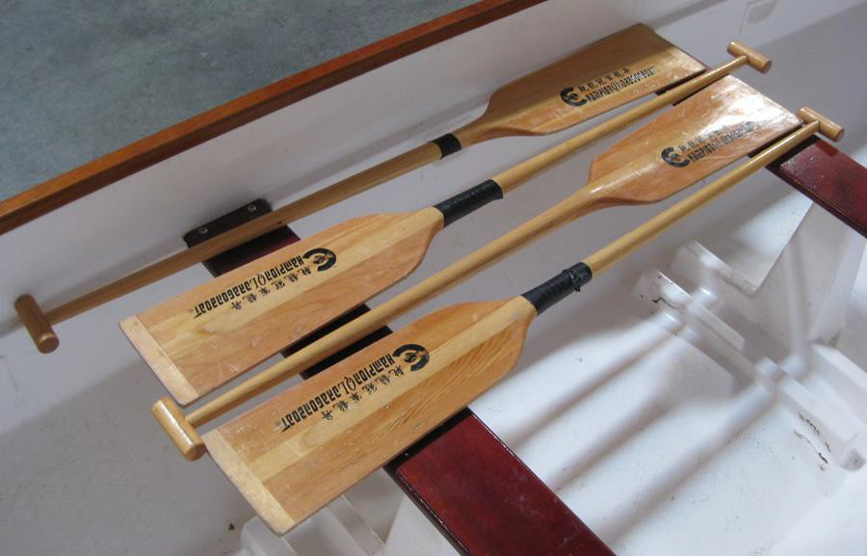

* + Lower the patient onto his back, positioning the chest/shoulders over the seat, while a person supports their head.

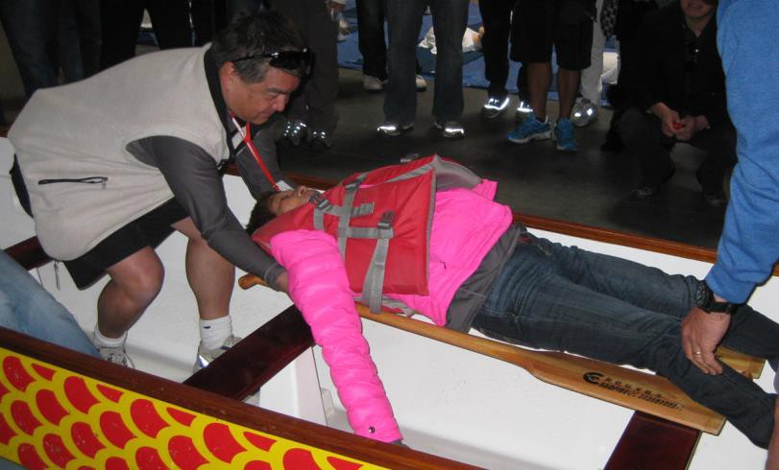

* + The CPR certified person should be at the patient’s side and start CPR after loosening PFD and having checked for heartbeat and breathing.
  + With the boat balanced, start paddling back to the nearest shore/dock.
  + Continue CPR until help arrives.
  + After returning to shore, immediately inform the beach monitor. Fill out the Formal Injury Report in Appendix 2 and email it back within 24 hours.

You should familiarize yourself with surrounding area street names to be able to provide better directions when talking to emergency personnel.

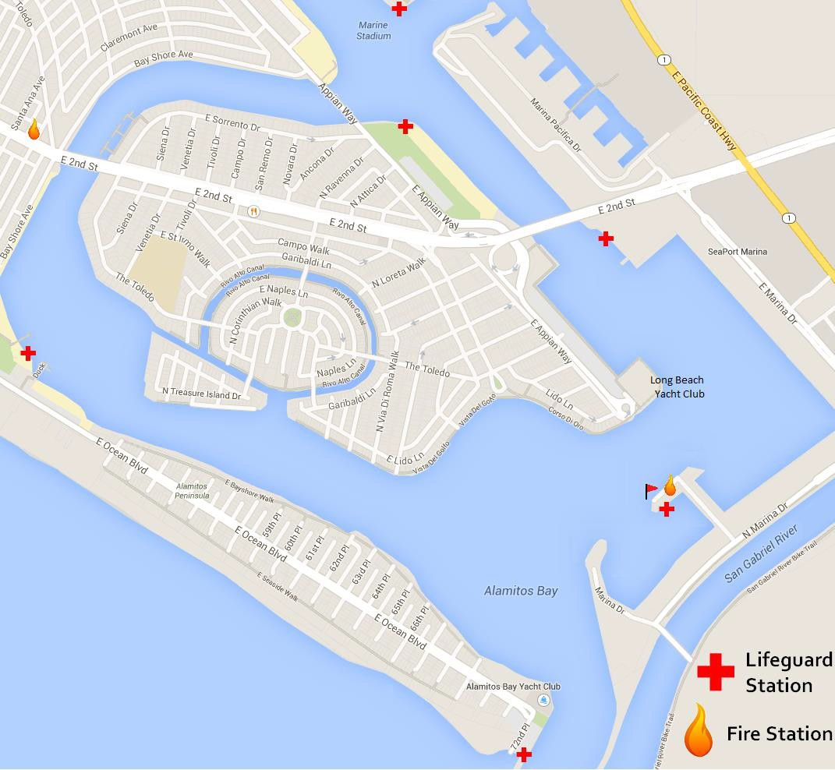

# What Is a PFD?

#### *U.S. Coast Guard PFD Policy*

The U.S. Coast Guard estimates that PFD's (Personal Flotation Devices) could have saved the lives of over 80% of boating fatality victims.

#### *Things to Know*

* PFDs are NOT one size fits all. Adult-sized PFDs will not work for children. Specially sized ones are available.
* PFDs come in different styles, which change their effectiveness in saving lives. Some PFDs are designed to keep your face above water and help you remain in a position which permits proper breathing.
* To work correctly, a PFDs must be worn correctly, fit snugly, and not allow your chin or ears to slip through.
* PFDs should be tested for wear and buoyancy at least once a year. Waterlogged or leaky jackets should be discarded.
* A PFD can help you survive in cold water.
* The SCDBC requires that everyone on the boat wear a non-inflatable, Coast Guard-approved, Type III PFD.

Other items you may want to have with you:

* A bailer or two on the boat in case of capsize
* A plastic whistle to attract attention or to signal for help
* A water-proofed cell phone to call for help. You may want to keep the Long Beach Life Guard saved in your phone: 562-570-1360
* Aspirin (a blood thinner) to be administered if a stroke or heart attack occurs
* An extra paddle to paddle steer in case the steering oar breaks

The California Department of Boating and Waterways recommends that boaters *always***:**

* Check the weather before heading out
* Properly wear your approved PFD
* Abstain from alcohol consumption while boating

# Dehydration

Dehydration occurs when you lose more fluid than you take in, and your body does not have enough fluids to carry out its normal functions. Children, older adults and those with chronic illnesses are most at risk. Dehydration can aggravate heat cramps, heat exhaustion, heat stroke, and hypothermia.

Mild to moderate dehydration is likely to cause:

* Dry, sticky mouth
* Sleepiness or tiredness
* Thirst
* Headache
* Dizziness or lightheadedness

Hot, humid weather increases the amount you sweat and the amount of fluid you lose. But you can become dehydrated in cooler temperatures as well.

Mild to moderate dehydration in otherwise healthy adults can usually be treated by drinking more fluids.

# Hypothermia

Hypothermia occurs when more heat escapes from your body than you can produce. Prolonged exposure to cold air or cold water are common causes. Dehydration, poor food intake, fatigue and more can also contribute.

The water in Long Beach averages 50-60˚, which is cold enough to cause hypothermia. Even if paddlers do not fall into the water, they can still be at risk, especially during non-summer or evening practices.

* **Watch for the "-Umbles"** - stumbles, mumbles, and fumbles which show changes in motor coordination and levels of consciousness

#### *Treating Hypothermia*

* **Reduce Heat Loss –** Get them out of their wet clothes and into dry clothing. If possible, get them indoors or at least out of the cold.
* **Add Fuel & Fluids** - Keep them adequately hydrated and fueled by feeding them hot liquids to drink and some sugars for energy. Avoid giving liquids with alcohol or caffeine, which will worsen hypothermia.
* **Add Heat –** Provide heat using an external heat source, like a car heater, or body to body contact.

# Heat Related Illnesses

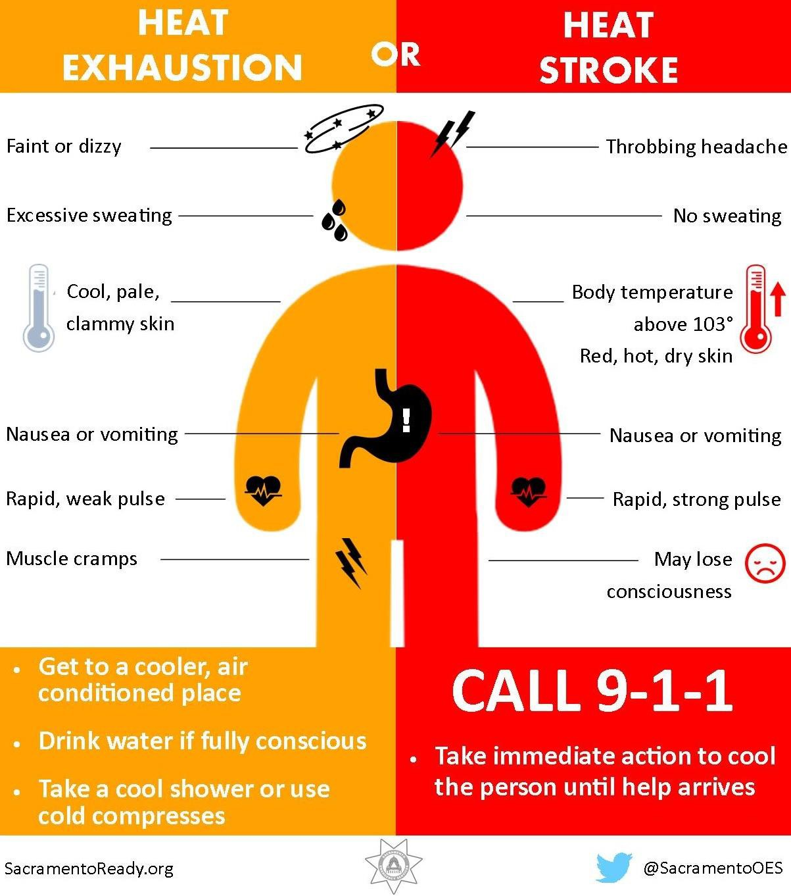

**Appendix 1: Formal Incident Report (generally: collisions and capsizes)**

## Formal Incident Report

Type of incident (collision, capsize, other):

Date and time of incident:

Location (include map if location is difficult to explain): Name of team(s) involved:

Names of Steer, Coach, Captain, Paddler involved:

Names of other Steers, Coaches, Captains present:

If relevant, describe weather and water conditions (include traffic if relevant):

Describe the incident in detail. You may include/attach diagrams, photographs, maps if that will help.

Any injuries:

Any damage to equipment, boat, other property (including bridges, docks):

Report written by: Date:

Title (steer, coach, captain, paddler):

Please email to [drchen@lbdragonboat.com](mailto:drchen@lbdragonboat.com), [H3OWAVE@aol.com](mailto:H3OWAVE@aol.com), [info@scdbc.org](mailto:info@scdbc.org), [tkclimb@aol.com](mailto:tkclimb@aol.com), and [steering@scdbc.org](mailto:steering@scdbc.org) within 24 hours of the incident.

**Appendix 2: Formal Injury Report (generally not related to collisions or capsizes)**

## Formal Injury Report

Date and time of incident:

Location (include map if location is difficult to explain): Person(s) injured and team:

Type of injury:

Describe the incident in detail. You may include/attach diagrams, photographs, maps if that will help. Please also include names of people who assisted.

Was emergency help notified? If so, which arrived?

Report written by: Date:

Title (steer, coach, captain, paddler):

Please email to [drchen@lbdragonboat.com](mailto:drchen@lbdragonboat.com), [H3OWAVE@aol.com](mailto:H3OWAVE@aol.com), [info@scdbc.org](mailto:info@scdbc.org), [tkclimb@aol.com](mailto:tkclimb@aol.com), and [steering@scdbc.org](mailto:steering@scdbc.org) within 24 hours of the incident.

**Appendix 3: Revision History (starting 5/15)**

|  |  |  |
| --- | --- | --- |
| **Date** | **Reviewer** | **Changes** |
| 5/2015 | Stephanie Shao, Anthony Chow | Revised Practice Steering Certification Requirements, added diagrams to same section. Added diagram to Learning How to Steer, added advanced techniques to “To Perfect Your Technique,” updated map in CPR to add “landmarks,” condensed heat related illnesses section,  miscellaneous changes |
| 9/2015 | Stephanie Shao | Deleted Heat Related Illnesses, added Heat chart, added Appendixes |
| 2/2018 | Iris Dulay | Updated status on steers and testing |